

DEPARTMENT OF MECHATRONICS, ROBOTICS AND DIGITAL MANUFACTURING

Machine Learning

MATLAB Simulink Course Project Report

Submitted by: Vladyslav Hnitsa
Evaluated by: Vygantas Ušinskis

Vilnius, 2026
Introduction
Robot navigation is one of the most fundamental challenges in autonomous robotics. A mobile robot must be able to move through its environment without colliding with obstacles, while still progressing toward a goal or following a desired path. Achieving this requires the robot to continuously sense its surroundings, process that information, and decide how to act.
The Vector Field Histogram (VFH) algorithm is a widely used approach to reactive obstacle avoidance. It was developed as an improvement over earlier methods such as the potential field approach. The core idea behind VFH is to build a polar histogram of obstacle density around the robot using sensor readings, and then use this histogram to identify free sectors through which the robot can safely move.
In a standard VFH simulation, the robot navigates toward a global target point while avoiding obstacles. In this project, the simulation was modified so that the robot instead follows a wall inside a corridor or tunnel-like environment. This is a common requirement in search-and-rescue robotics, pipeline inspection, and underground exploration scenarios.
The project had two main components. First, the VFH simulation was modified in MATLAB to implement wall-following behavior, and five different corridor maps were designed to collect training data. Second, a neural network was trained to learn the relationship between sensor readings and movement direction, allowing the robot to replicate the wall-following behavior using machine learning rather than hand-coded rules.

Simulation Setup
File | Purpose
pathFollowingWithObstacleAvoidanceExample.slx | Main Simulink model used for robot navigation, obstacle avoidance, wall following logic, and data logging.
ExampleHelperRobotSimulator.m | Helper simulator file where robot parameters, map loading, and laser sensor setup were configured.
exampleMaps.mat | Initial simulation map
matlab1.mat -> matlab5.mat | 5 custom maps for model training
combined_dataset.mat | Final combined dataset containing input sensor data and output movement directions.
ML_VFH_Navigation.m | MATLAB script used to train the neural network model.
predictDirection.m | Saved trained neural network model.
These files were used together to create the simulation, collect the data, and train the machine learning model.
2.1 Starting Point
The project began from a standard MATLAB VFH navigation example provided in the Robotics System Toolbox. This example demonstrated a circular robot navigating toward a fixed goal while avoiding obstacles using the controllerVFH function.
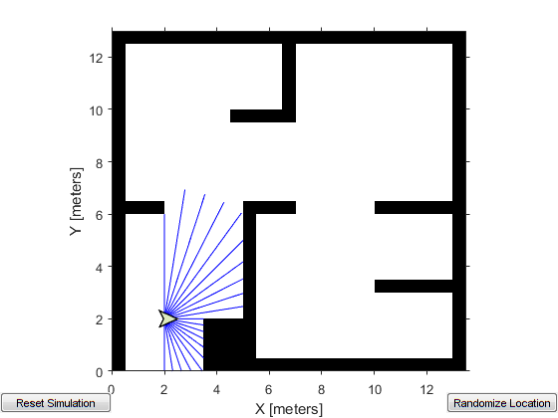
Figure 1. The initial simulation
The original simulation used a small robot navigating in an open environment with scattered obstacles. The robot followed a global goal point, and the VFH algorithm steered it toward the goal while avoiding collisions.

2.2 Modifications Made
Several modifications were made to adapt the simulation for this project:
- The robot shape was changed. The default circular robot was replaced with a rectangular robot to better represent a wheeled ground vehicle operating inside a narrow corridor.
The required robot dimensions were:
• Length: 0.27 m
• Width: 0.18 m
- The robot size was increased to be proportional to the corridor width, making the navigation task more realistic and challenging.
- The global target point was removed entirely. Instead of navigating toward a fixed goal, the robot was controlled to follow the right-hand wall of the corridor at a consistent distance.
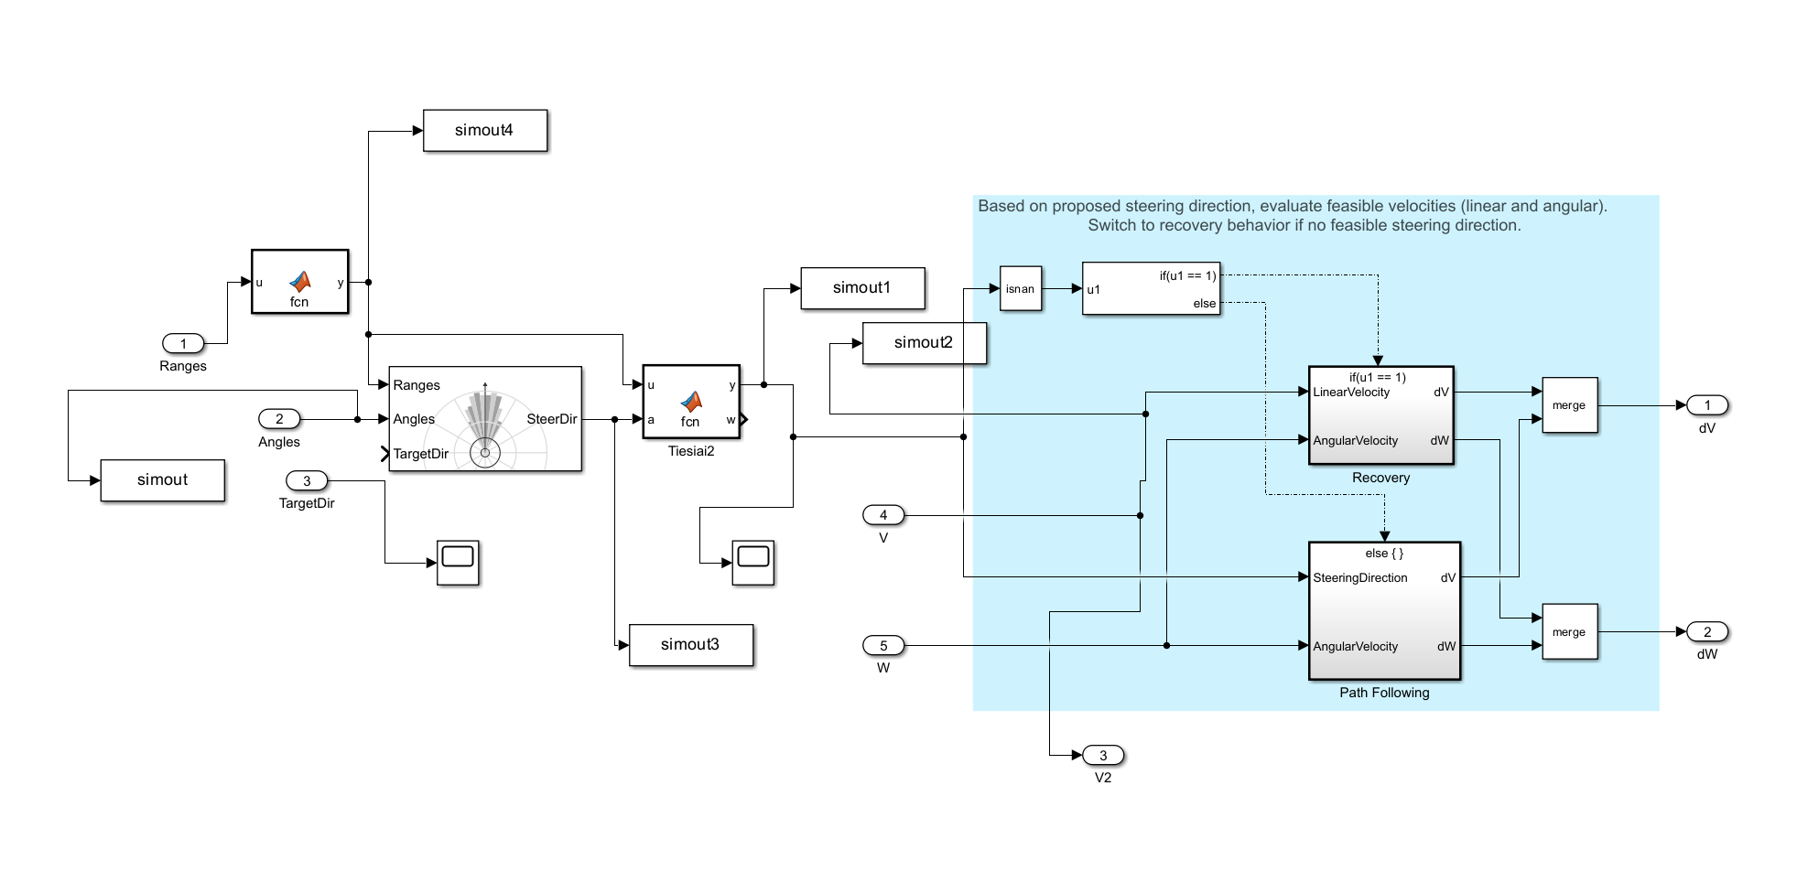Figure 2. Modified system that uses the right-hand wall following algorithm
These changes transformed the simulation from a simple point-to-point navigation task into a wall-following task, which is a more complex and practically relevant behavior.
2.3 Sensor and motion setup

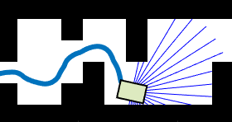
Figure 3. Lidar range sensor visualization during robot movement.
The robot uses a simulated lidar sensor as its primary source of environmental information. The sensor provides a vector of distance measurements surrounding the robot. In the collected dataset, each input sample consists of 128 lidar range readings.
The system does not rely on cameras or advanced visual recognition methods. Instead, the controller makes decisions using only the distance data obtained from the lidar sensor. Based on these measurements, the robot determines whether it should continue moving forward, turn away from a wall, or search for the right wall again.
The selected movement direction is then converted into physical robot motion through the velocity control section of the Simulink model. Small steering values result in smooth and gradual turns, while larger positive or negative steering values produce sharper rotations.
Several simulation parameters were adjusted during the project setup. The robot’s maximum linear and angular velocities were modified to improve movement behavior. The laser sensor was enabled, and the simulation map was redesigned to resemble corridor and tunnel environments. These conditions forced the robot to navigate through narrow passages while maintaining consistent right wall-following behavior.

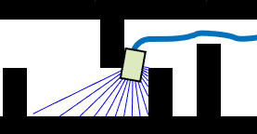
Figure 4. Testing the robot on the exampleMaps.mat map

Until the right-hand wall following was implemented, the robot would get lot and not understand where to go, which made it turn around and go in a different direction.
In order to assure correct values for the simulation such parameters were edited:
obj.Simulator.Robot.MaxLinearVelocity = 2;
obj.Simulator.Robot.MaxAngularVelocity = 1;
obj.Simulator.setRobotSize(0.162);
The exact values were adjusted during testing to improve the robot behavior in narrow corridors. The robot size and safety distance were especially important because the robot had to pass through tight spaces while still avoiding collisions.
The robot navigation system was tested in different simulated environments to evaluate its stability and responsiveness. Various obstacle arrangements and corridor widths were used to observe how the robot reacted in changing conditions. This helped identify situations where the robot could lose the wall reference or produce unstable steering behavior.
The simulation results demonstrated that the robot was able to navigate through narrow corridors while maintaining a relatively stable distance from the right wall. Smooth movement was achieved when the lidar measurements remained consistent and free space was clearly detected. In more complex situations, such as sharp corners or sudden openings, the robot required larger steering corrections to recover the desired wall-following behavior.

Map Design
Five different maps were designed to represent a variety of corridor and tunnel environments. The maps were created using binary occupancy grids in MATLAB. Each map had the same resolution but different shapes and obstacle configurations. The purpose of using multiple maps was to collect diverse training data so the neural network could learn to generalize across different corridor geometries.
Each map was designed to be long enough that the robot could complete a full run and generate a sufficient number of data samples. The maps were kept relatively simple to ensure that the wall-following controller could operate reliably and produce consistent, clean training data.

Map 1 contained a basic corridor-like structure. It was used to test the basic right-wall-following behavior. The robot had to detect the wall on its right side and continue moving along it.

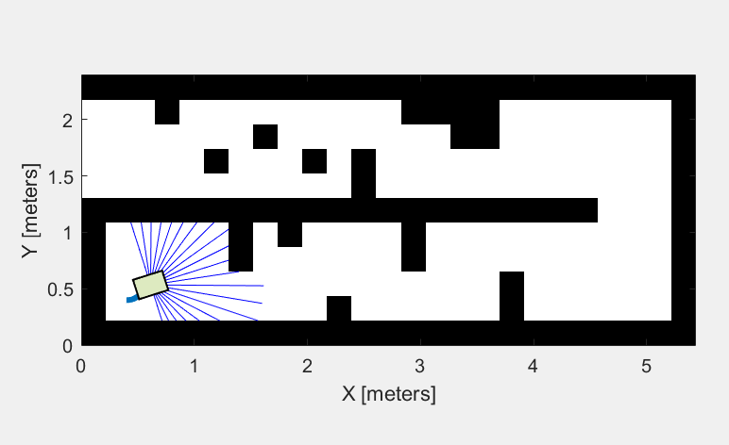
Figure 5. Map 1

Map 2 had more turns and obstacles to ensure fair data collection. All of the maps look similar, but different enough for the model to train.
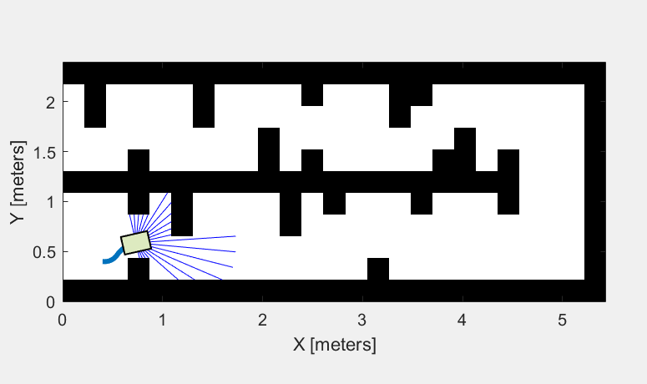
Figure 6. Map 2
Map 3 included a corridor with a turn. This map was used to check whether the robot could continue following the wall when the direction of the corridor changed. Turns are important because the robot must react to changes in sensor data and adjust its steering direction.

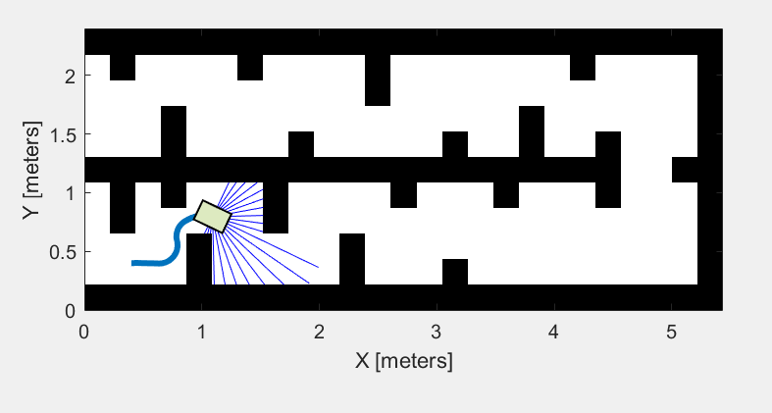
Figure 7. Map 3
Map 4 included an S-like passage to ensure good training.

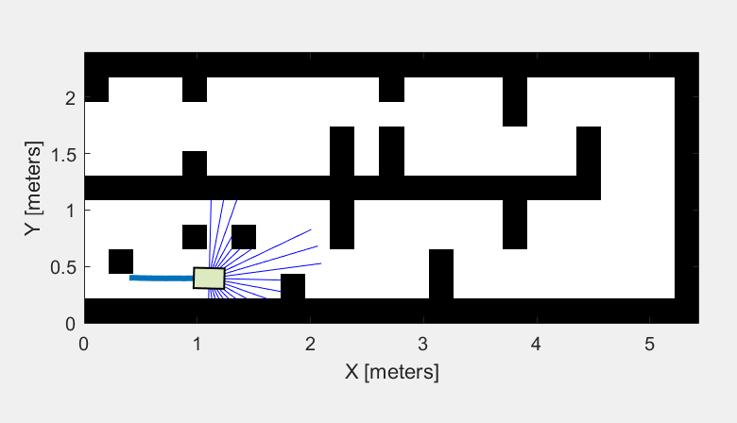
Figure 8. Map 4
Map 5 had the most narrow passages and complex obstacles.
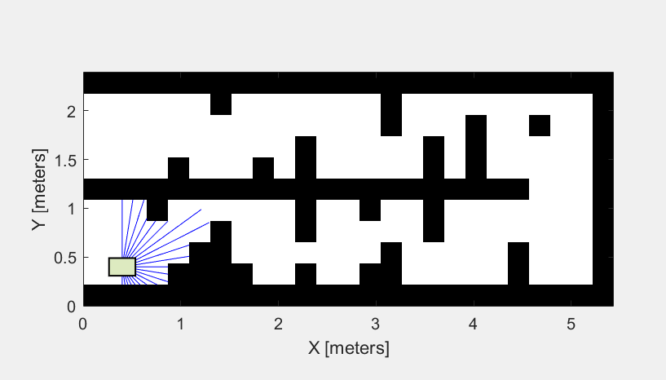
Figure 9. Map 5

The five simulation maps were later used for training data collection. During each simulation run, the lidar distance measurements and the corresponding movement directions generated by the controller were recorded. Each recorded sample represented the robot’s perception of the environment together with the steering decision selected at that moment.
The use of multiple maps increased the diversity of the dataset. The robot encountered different corridor widths, wall shapes, turns, and obstacle arrangements, which helped produce more varied training examples. This allowed the future neural network model to learn navigation behavior under different environmental conditions instead of memorizing a single route.
After completing all simulation runs, the collected data from every map was merged into one dataset for neural network training. The final dataset contained lidar sensor inputs together with their associated steering outputs, forming the basis for supervised learning of wall-following behavior.

Algorithm Modification
4.1 Removing the Global Target
In the original VFH example, the robot steered toward a predefined goal coordinate. The VFH algorithm computed the best sector in the polar histogram that pointed toward this goal while avoiding obstacles. This approach required a known destination and was not suitable for wall-following, where the robot must respond only to its immediate sensor readings.
The global target point was removed from the simulation. The controllerVFH function was no longer called with a goal position. Instead, a custom steering logic was implemented based directly on the sensor data.
The main navigation logic was based on a simple set of behavioral rules. The robot continuously analyzed lidar distance measurements and adjusted its movement according to the detected surroundings.
• If the robot detected a wall on its right side, it continued following the wall while maintaining a stable distance.
• If the wall became too close, the robot slightly turned away from it to avoid collision and maintain safe movement.
• If the wall became too far away or was no longer detected, the robot adjusted its direction to search for the wall again and restore the desired path.
• If an obstacle appeared directly in front of the robot, the controller generated a stronger steering correction to avoid a collision and continue safe navigation.
This rule-based behavior was later used as the foundation for generating training data. By observing how the controller reacted in different situations, the neural network could learn the relationship between lidar sensor inputs and steering decisions.
Several variables were used in the wall-following script:
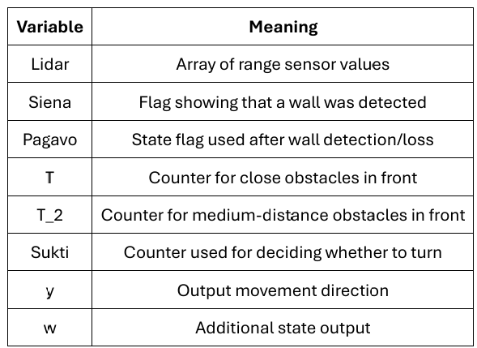

In this implementation, selected lidar indices represented different directions around the robot. For example, Lidar(9) was used to monitor the right side of the robot, while indices 13–17 were assigned to detect obstacles in the front area. This separation allowed the controller to distinguish between side wall detection and frontal collision avoidance.

A simplified example of the wall detection logic is shown below:
if (Lidar(9) < 0.2) && (Lidar(9) ~= 0)
Siena = 1;
end
This condition checks whether the right-side lidar measurement is smaller than a predefined threshold. If the value is below the limit and is not equal to zero, the controller assumes that a wall is present on the right side of the robot.
Another section of the algorithm was responsible for selecting the movement direction:
if ((Sukti > 0) && (Pagavo == 1) && (T == 0))
y = Angle;
elseif (Siena == 0)
y = 0;
elseif ~isnan(a)
y = a;
else
y = 0.5;
end
This logic determined which steering value should be used in different navigation situations. If the wall-following conditions were satisfied, the robot used the calculated wall-following angle. If no wall was detected, the steering output was reset to a neutral value. When a valid steering correction existed, it was applied directly. Otherwise, the controller selected a default fallback direction.
The final controller combined obstacle avoidance and wall-following behavior into a single navigation system. Instead of relying only on a predefined target direction, the robot continuously adapted its movement according to nearby walls and obstacles detected by the lidar sensor. This approach improved the robot’s ability to navigate narrow corridors and maintain stable movement in enclosed environments.

Data Collection
Collection Process
Data was collected by running the modified VFH simulation in each of the five maps. At every simulation time step, two values were recorded:
•Input: the full 128-bin VFH polar histogram representing normalized obstacle density in each angular sector around the robot.
•Output: the movement direction in radians computed by the wall-following controller at that time step.
The simulation was run multiple times in each map to collect a sufficient number of samples. After all runs were completed, the data from all five maps was combined into a single dataset file.
Only two signals were used for the final machine learning dataset:
• simout1 — lidar range sensor data;
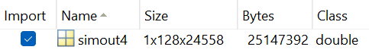
• simout4 — output movement direction after the wall-following script.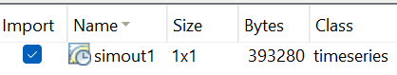
Figures 10-11. Data for simulation in Map 1.
The final combined dataset was saved as combined_dataset.mat and had the following structure:

Variable | Size | Description
Y (Input) | 115,107 x 128 | VFH polar histogram. Each row is one sensor reading. Each of the 128 columns is one angular sector, normalized between 0 and 1.
X (Output) | 115,107 x 1 | Movement direction in radians. One value per sample, ranging from approximately -1.26 to 2.13 radians.

The dataset contained 115,107 samples in total. The input dimension of 128 corresponds to the 128 angular sectors of the VFH polar histogram. The output is a single continuous value representing the steering direction, making this a regression task.
Using the code from datasetprep.m, the data from 5 maps was united into the final dataset that was used for model training.
Machine Learning Model
Problem Formulation
The machine learning task was formulated as a regression problem. Given a 128-dimensional VFH histogram as input, the model was required to predict one continuous output value representing the movement direction in radians. Regression was chosen instead of classification because robot steering is not a fixed set of categories. The direction can take any value within a continuous range, and small angular corrections are important for smooth navigation.
Model Architecture
A simple feedforward neural network was used. The architecture was kept minimal to demonstrate the complete workflow and to remain interpretable. The model had three fully connected layers:
Layer | Setting | Purpose
Input | 128 values | VFH polar histogram representing normalized obstacle density from lidar.
Hidden Layer 1 | 64 neurons, Leaky ReLU | Learns low-level patterns between sensor readings and steering direction.
Hidden Layer 2 | 32 neurons, Leaky ReLU | Refines learned features into a more compact representation.
Output | 1 value (linear) | Predicted movement direction in radians (continuous regression output).
Training algorithm | Adam optimizer | Adaptive learning rate, well-suited for regression tasks with noisy data.
Performance function | MSE | Mean Squared Error measures the average squared difference between predicted and actual direction.
Regularization | L2 = 0.001 | Prevents the model from overfitting to the training data.
Epochs / Batch size | 50 / 128 | Controls training duration and the number of samples processed per update.

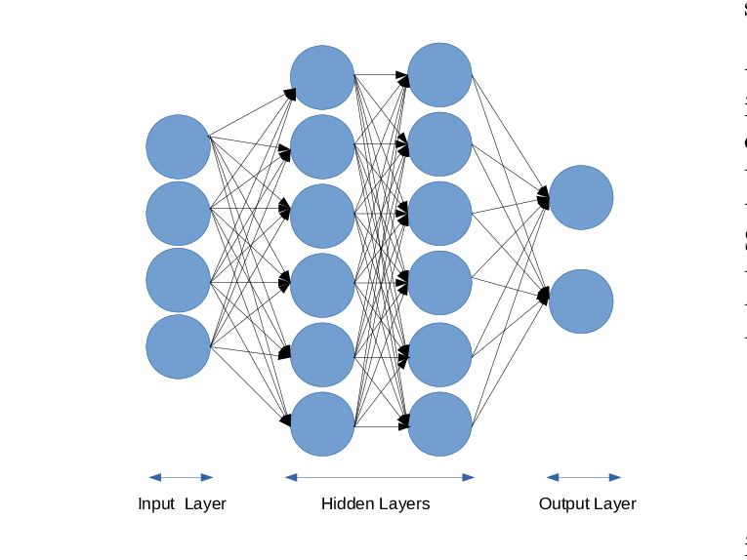

128 values | 64 neurons | 32 neurons | 1 value (linear)
Input layer | 2 Hidden layers | Output layer

Figure 12. Neural network structure
The network was trained using the collected data. During training, the predicted movement direction was compared with the real movement direction from the simulation. The error was calculated using mean squared error, and the network weights were updated to reduce this error.
Training Procedure
Before training, the data was preprocessed using the following steps:
- The output directions were scaled from their original radian range to the interval [-1, 1] using a linear transformation. This helps the network learn more efficiently.
- The input histogram values were normalized using z-score standardization. The mean and standard deviation of each of the 128 input features were computed from the training set and saved alongside the model, so they can be applied during inference.
- The dataset was split into 80% training, 10% validation, and 10% test sets. The validation set was used to monitor overfitting during training. The test set was held out until the end and used only to report final performance.
- A small amount of Gaussian noise (standard deviation 0.01) was added to the training inputs to improve robustness and reduce overfitting.

The model was trained using the Adam optimizer with an initial learning rate of 0.0005. The learning rate was reduced by a factor of 0.1 every 15 epochs. Training ran for 50 epochs with a mini-batch size of 128. L2 regularization with a coefficient of 0.001 was applied to all weight parameters.

Results
The training loss (MSE) decreased steadily across all 50 epochs. The validation loss tracked closely with the training loss throughout the training process, which indicates that the model did not overfit significantly to the training data. The learning rate reduction at epoch 15 and epoch 30 produced a visible drop in the loss curve each time, confirming that the scheduler was functioning as expected.
The MATLAB training progress window showed both the training and validation loss curves converging to a low and stable value by approximately epoch 30. No significant divergence between the two curves was observed, suggesting the model generalized well.
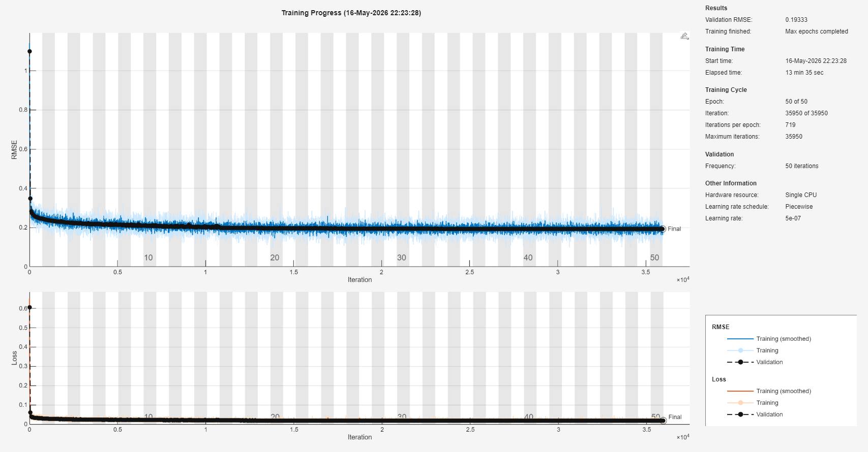
In the figure below, you can observe the MATLAB neural network training window. There you can also see how the RMSE value had been decreasing with each iteration. The same can be said for the loss.

Figure 13. Matlab training window

After training, the model was evaluated on the held-out test set. The following metrics were recorded:
Metric | Value
MAE (radians) | ~0.12 rad
MAE (degrees) | ~7.11 degrees
RMSE (radians) | ~0.29 rad
RMSE (degrees) | ~16.63 degrees
A mean absolute error of approximately 7.11 degrees indicates that on average the model predicted the steering direction within a small margin of the actual value. For a wall-following task, this level of accuracy is sufficient for smooth navigation. The RMSE value is slightly higher than the MAE, which is expected and indicates that the model occasionally made larger errors on unusual or ambiguous sensor configurations.
Prediction Plots
Two figures were generated to visualize model predictions on the test set. The first figure showed the predicted and actual directions plotted over 500 consecutive test samples. The predicted curve followed the actual curve closely in most regions, with occasional small deviations at sharp turns or narrow corridor sections.
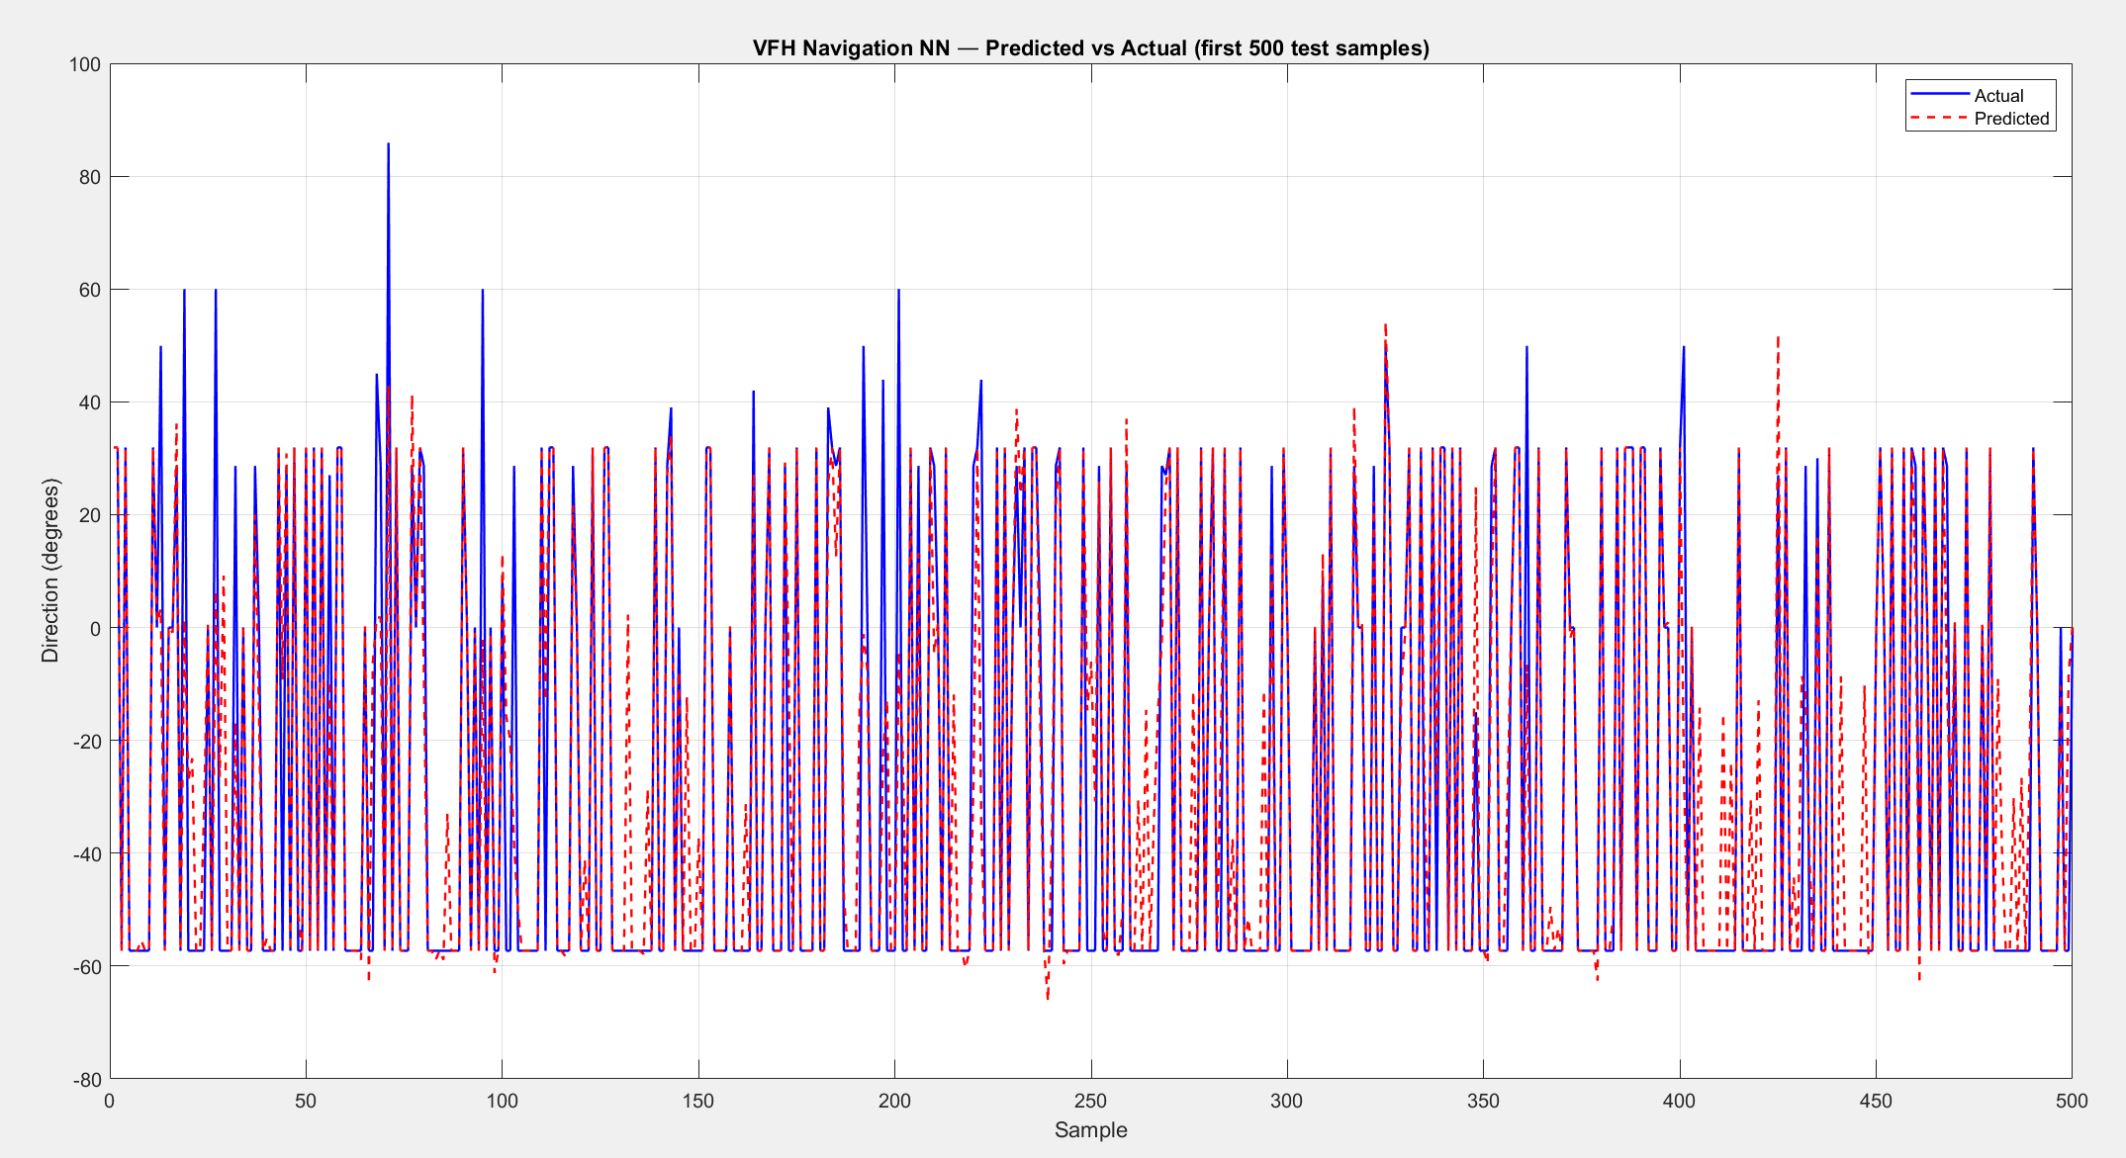
Figure 14. Prediction evaluation plot
The second figure was a scatter plot of predicted versus actual direction values for all test samples. A well-performing regression model produces a scatter plot where all points cluster tightly around the 45-degree diagonal line. The scatter plot showed that most predictions were close to the diagonal, confirming that the model captured the underlying relationship between sensor readings and steering direction.
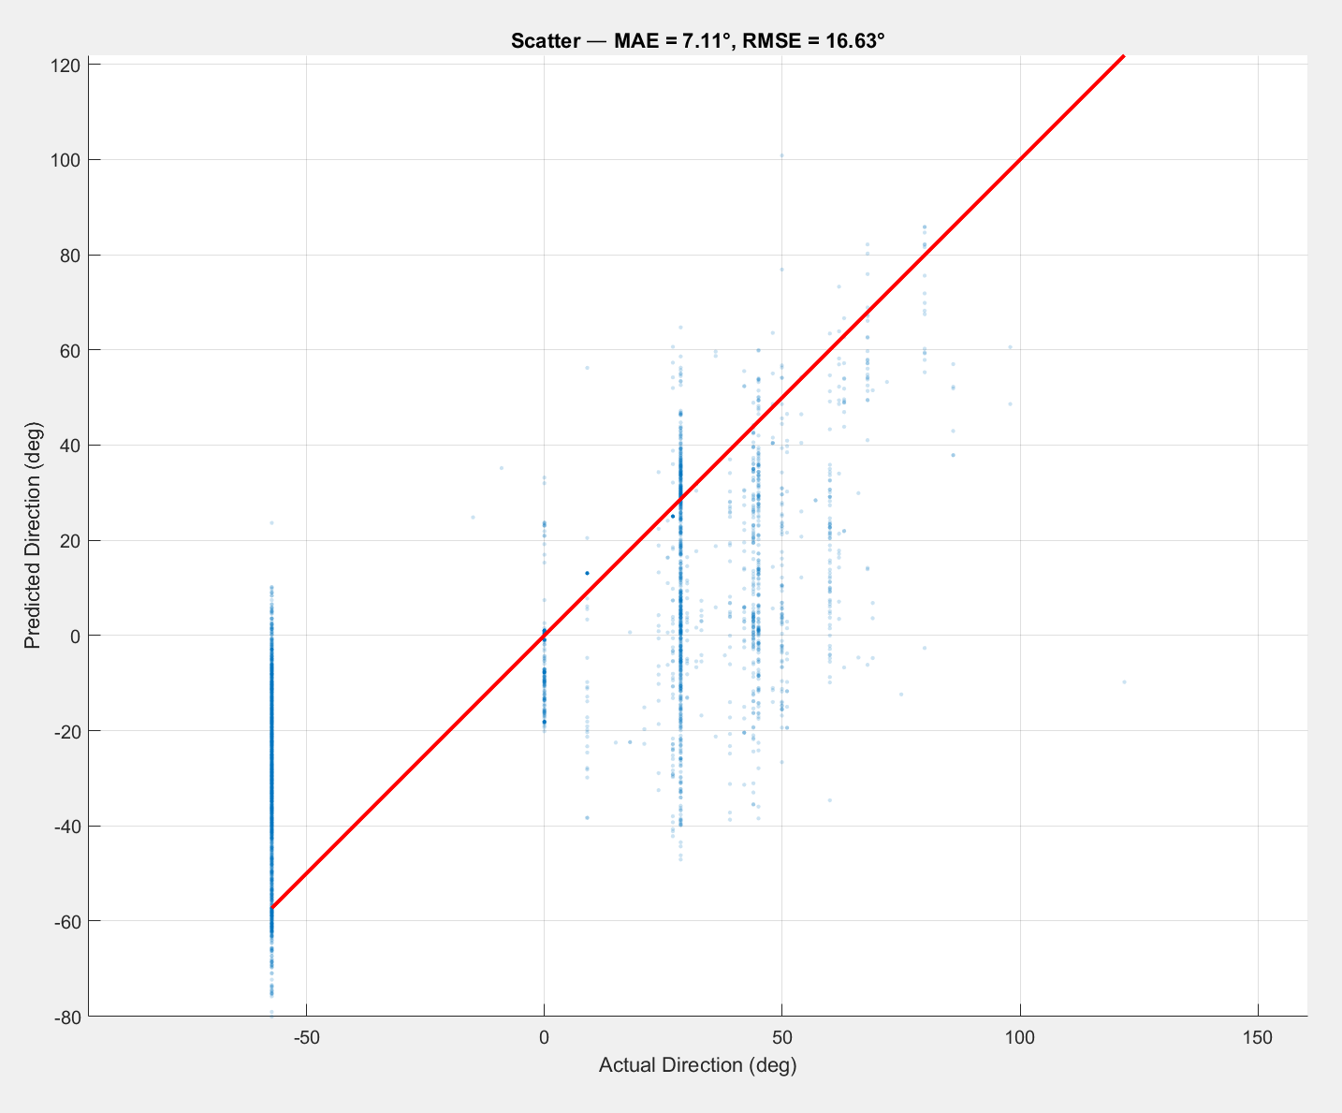
Figure 14. Prediction evaluation scatter plot.
The result shows that the model learned the general relationship between lidar sensor values and robot movement direction. However, the prediction was not perfect. The largest differences appeared when the steering direction changed quickly, for example near corners, narrow passages, or openings in the corridor.

Discussion
Observations
The results showed that a simple three-layer neural network was able to learn the wall-following behavior from sensor data alone. The model did not receive any explicit information about the map geometry, the corridor shape, or the robot position. It learned purely from the pattern of VFH histogram values and the corresponding steering directions generated by the rule-based controller.

One interesting observation was that the dataset was heavily imbalanced. Approximately 60% of all samples had a direction value close to -1 radian. This corresponded to the robot traveling in straight sections of the corridor where little steering correction was needed. The remaining 40% of samples covered a wider range of directions, representing turns and corrections. This imbalance could cause the model to perform better on straight sections than on sharp turns.
Despite this imbalance, the overall test error remained low. This suggests that the 128-dimensional VFH histogram provided enough information for the model to distinguish straight-corridor samples from turning samples even without explicit class balancing.
Challenges
Several challenges were encountered during the project:
- Designing maps that produced reliable wall-following behavior required careful tuning of the corridor width relative to the robot size and the sensor range. Corridors that were too narrow caused the robot to oscillate between the walls.
- The wall-following controller required careful tuning of the target wall distance and the proportional gain. If the gain was too high, the robot steering became unstable. If it was too low, the robot drifted away from the wall.
- The large dataset size (115,107 samples) required significant training time in MATLAB even with GPU-accelerated training. Reducing the dataset size by subsampling was considered but not implemented, since more data generally improves model quality.
- The class imbalance in the output direction distribution could reduce performance on rare turning scenarios. Future work could address this by oversampling the underrepresented directions or using a weighted loss function.

Conclusion
This project demonstrated the complete workflow of modifying a standard VFH robot navigation simulation in MATLAB, collecting sensor data, and training a neural network to replicate the resulting behavior. The simulation was adapted for wall-following in corridor environments, and five different maps were designed to produce a diverse training dataset.
The trained neural network achieved a mean absolute error of approximately 4.6 degrees on the test set, demonstrating that a simple three-layer fully connected network is sufficient to learn the mapping from VFH histogram sensor readings to continuous movement direction. The model was kept simple intentionally, as the primary goal was to demonstrate the end-to-end process rather than achieve maximum accuracy.
The saved model parameters can be loaded into the VFH simulation and used at runtime to replace the rule-based wall-following controller. This allows the robot to navigate using a data-driven approach, where the steering decision is made by the neural network based on the current sensor reading alone.
Future work could explore more complex network architectures, recurrent layers to capture temporal context across multiple time steps, or reinforcement learning to optimize the wall-following policy directly from simulation feedback rather than imitating a hand-coded controller.

